**GIT LOG SCREENSHOT**

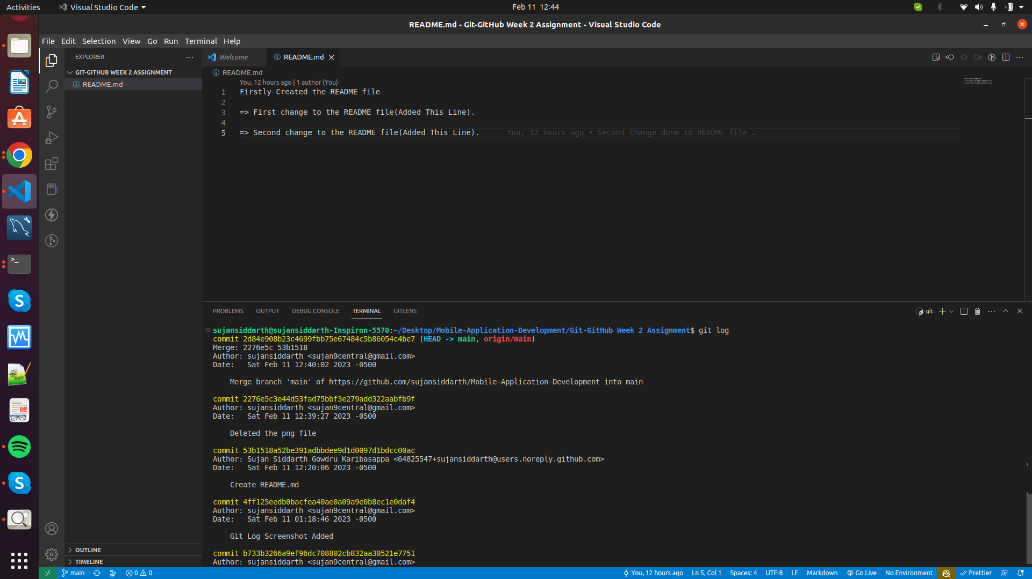

**GITHUB HISTORY SCREENSHOT**

